Binary File Handling assignments

Mandatory

- WAP to
- read 2 names (each of maximum length 20 char), and ages (uint) from the user.
- Store the names in heap allocating required memory and ages in array. [You may also use a structure to keep name and age].
- Write using fwrite() each name and age pair as comma separated pair to the binary file “out.bin” one per line . Close the file after saving.
- Open the file, using fread() read each name and age pair and display
- Verify if the displayed contents are same as that read from the user.
- What was the
- Size of Each name and age pair (based on input read)
- Total sizeof 2 name and age pairs (based on input read)
- Size of file
- What do you observe between bytes read and bytes stored?
- Open file and see its content. Is it readable?
- Free allocated memory
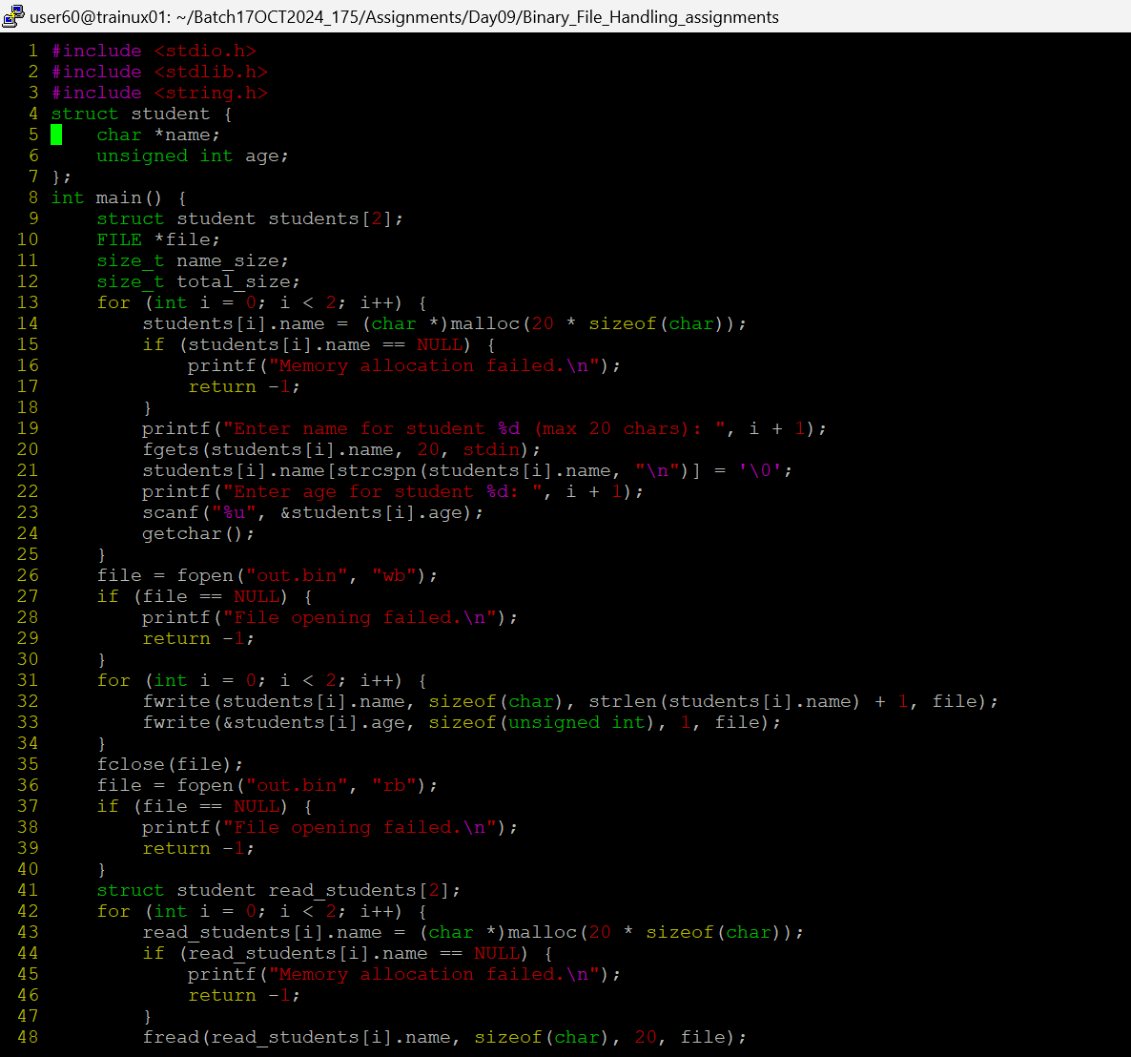
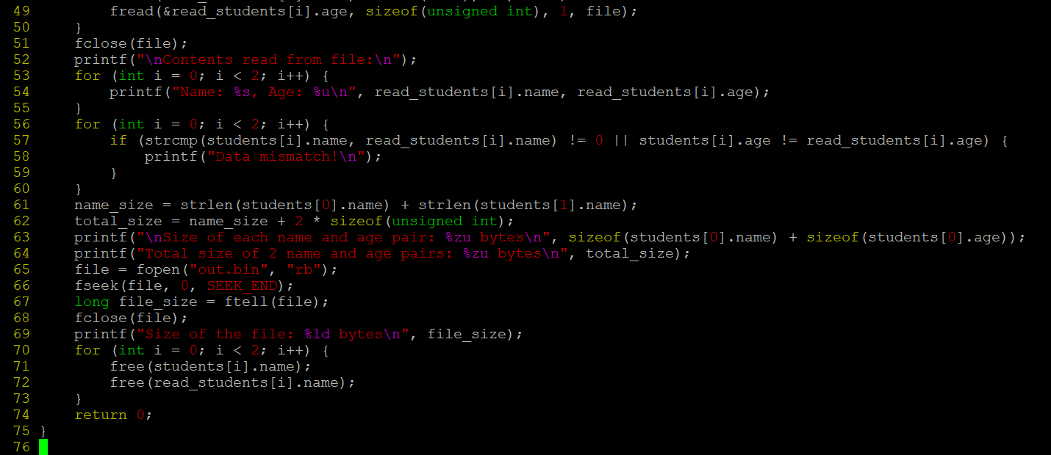
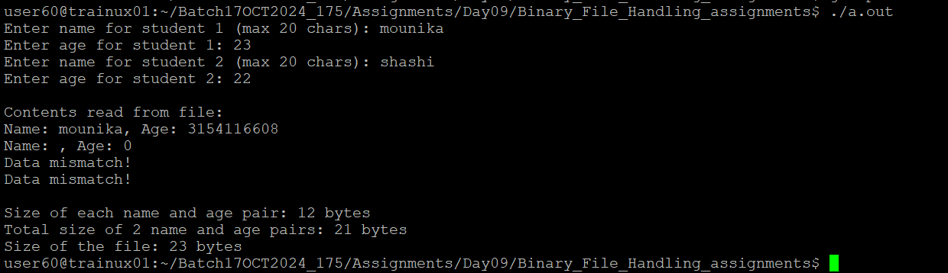
- WAP to read 2 or more server configuration details from the user and to process it as per given requirements. Refer the configuration structure as below.
#define MAX_CFG 5 //Maximum number of configurations
#define MAX_LEN 50
typedef struct config
{
char *ipaddress; // pointer to a dotted ip address string
char name[MAX_LEN];
unsigned short port;
}CONFIG;

CONFIG cfgarr_in[MAX_CFG];
CONFIG cfgarr_out[MAX_CFG];

- Read and store the input configuration in cfgarr_in
int read_store_cfg(cfgarr);
- Display the stored configuration
void display(cfgarr, int count);
- Store the configuration in a binary file “out.bin” using fwrite()
- Read from the file using fread() and store in a cfgarr_out
- Display the contents of cfgarr_out and verify it with content read from user in a).

